* **Identify and visually represent the top 10 product categories by total sales.**

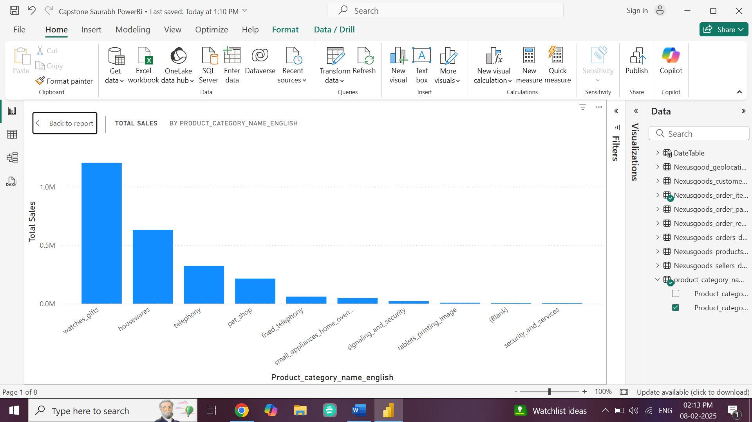

* There's a sharp decline in sales after the top two categories, indicating dependency on a few product lines.
* To diversify revenue we will need to focus on expanding and promoting low selling goods.
* We can also see that daily needed items are more sold as compared to other items.
* We can thus create awareness through media marketing and other marketing source and increase the sale and hence the revenue will also increase.
* **Determine the number of delayed orders in each category. An order is considered delayed if the actual delivery date is later than the estimated delivery date.**

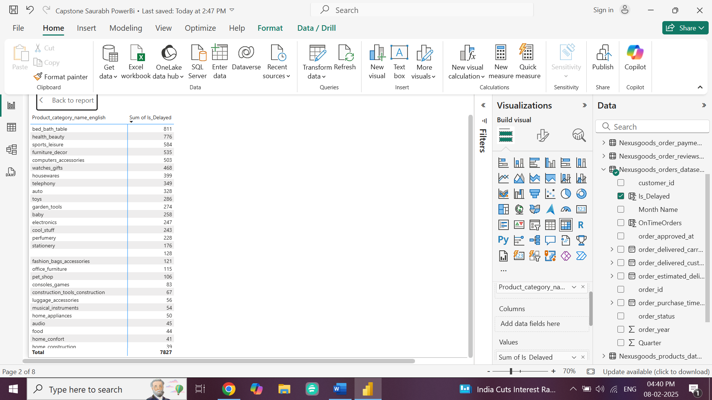

* The total number of delayed orders across all categories is **7,827** which is almost ***10*** *percent of total orders*, suggesting opportunities to improve delivery logistics.
* We can also see that some of the running items are delivered late due to which it affects revenue so if we focus more on delivery and logistics part and see why delivery are getting late revenue can be increased.
* Also we can see most of delayed items which are at top most position are being seen in bottom position of sale, hence we can increase by focusing and giving on time delivery there by satisfying customer we can also increase revenue.
* **Create a dynamic visual that compares the number of delayed orders to the number of orders received earlier for each month. Utilize the drillthrough cross-report feature to provide a detailed analysis of late and on-time deliveries.**

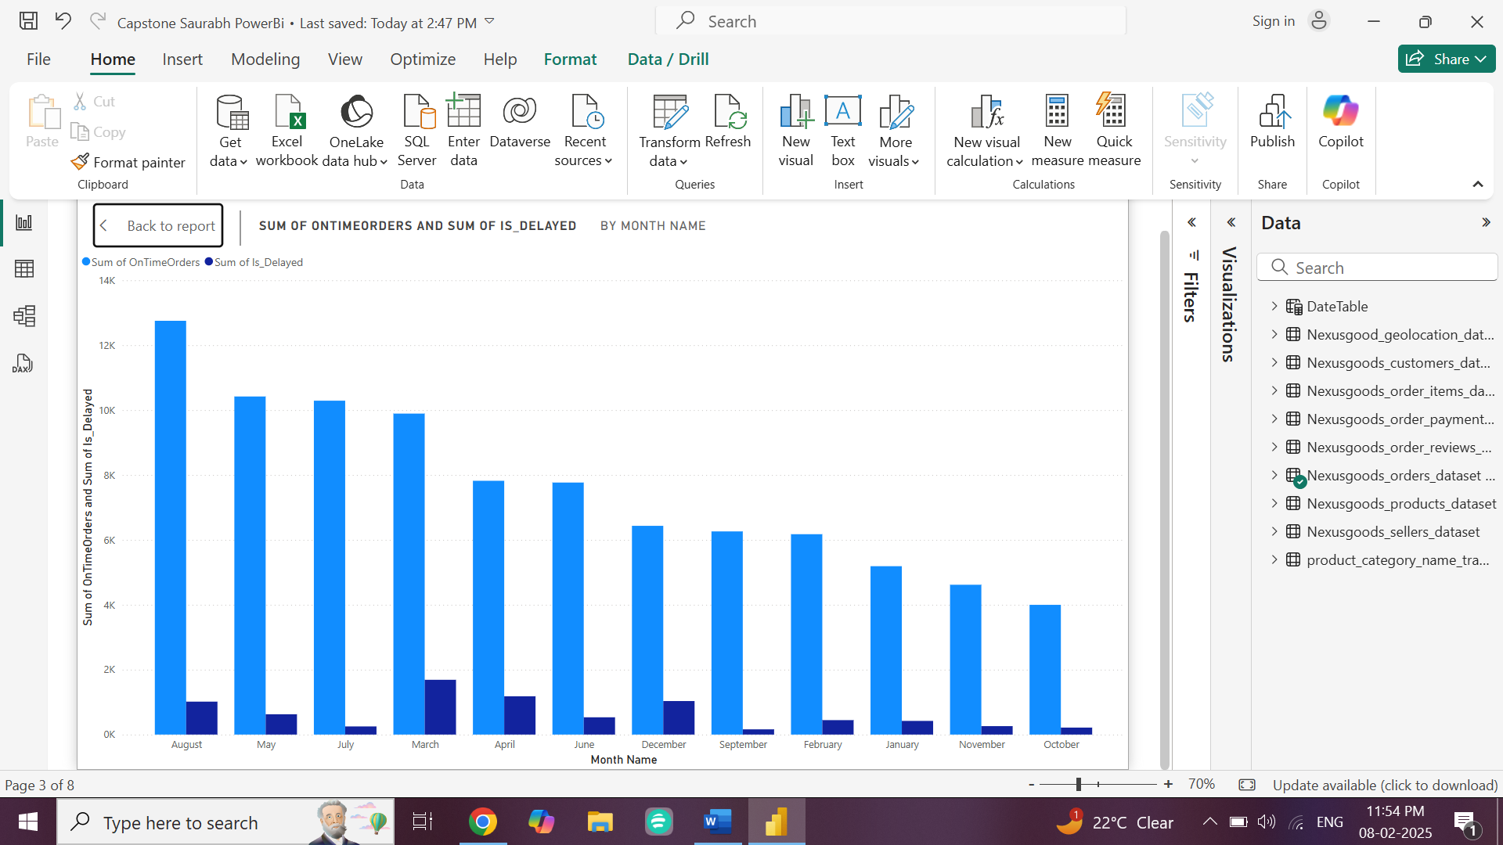

* In the month of August we can see on time orders high and moderate delay so focus can be made so that delay orders reason can be found out quickly compared to others.
* In similar way October and November have low orders and also minimum delays which suggests management is done properly as rush is less.
* Also, in month of April and March High orders are there also rate of delay orders is high. The reason may be full season orders and management issues as more orders were there so need proper investigation for the same and may be if found out we can reduce overall delay orders time.
* **Analyze the most frequently used payment methods by customers using a visually appealing representation, such as a pie chart or other suitable visuals.**

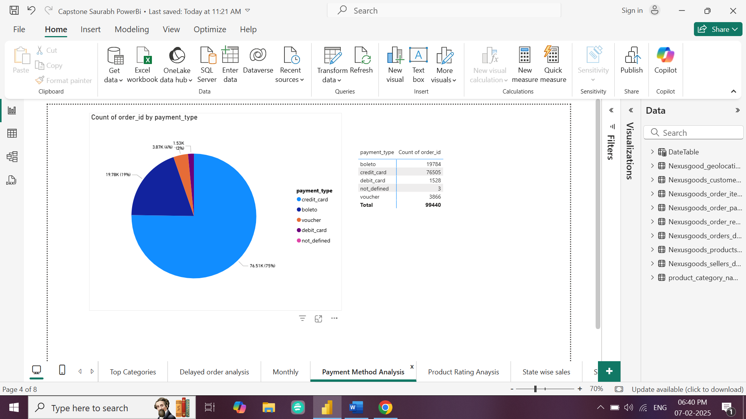

* We can see that most of the payment is done through credit cards, which shows more payment is done by credit cards.
* From the above pie chart and data we can see that “boleto” which means it payment mode used by Brazilian banks used for more secured in form of cash is used for the payment after credit cards
* Least mode used is vouchers and debit cards.
* So we can conclude that if store can give offers on Credit Cards and to boleto mode one can increase the revenue and hence sale can be increased with offers on credit cards as population and usage of credit cards is more in that place.
* **Determine the top 10 highest-rated products and the bottom 10 lowest-rated products using a bar or column chart.**

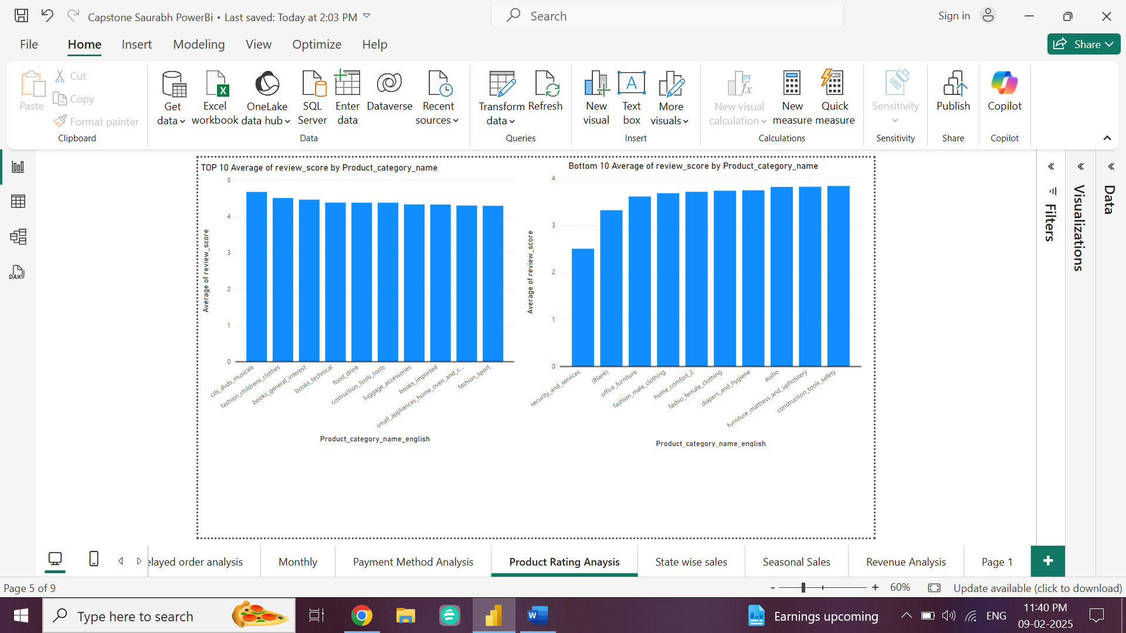

* From the reports we can see that DVDs, musical instruments, fashion, books , food drink ratings are high.
* Fashion (children and sport) products also perform well, indicating good quality or customer alignment.
* Tech-related categories like pc accessories and consoles games also have favourable reviews.
* Security and services have the lowest satisfaction, potentially due to service issues or not updated security.
* Office furniture and home comfort products are rated poorly, which may reflect on comfort or durability issues.
* Fashion categories (male and female) also show low ratings, indicating possible problems with fit, style, or quality.
* From this we can conclude that those items which are not required daily or not in essential needs are low rated hence we need to create proper promotion activity and mainly focus on people’s feed back to create customer satisfaction on these items.
* **Identify and visually represent states with high and low sales, providing a clear understanding of regional sales performance.**

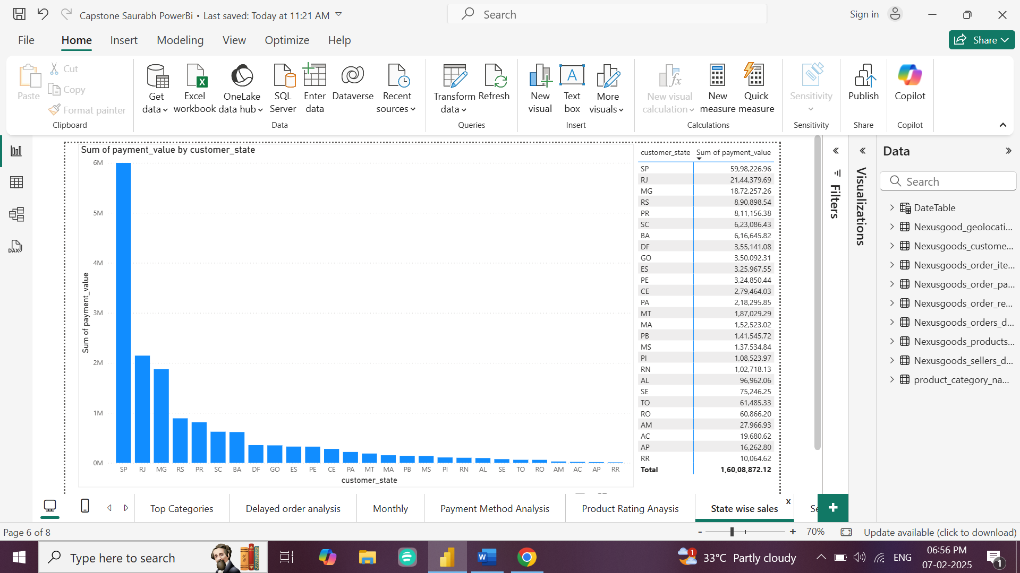

* From above analysis we can see that States from South America Brazil contribute more in sales compared with other states.
* So, awareness and promotion will be required in other parts of the world other than in South America.
* As we can see dependency is mainly in Southern part as more than 70 percent of sale is from this part.
* Also, major states of performing low are from same region which indicates some issues regarding promotion or services from stores as same region but other states are performing well, also purchasing power of requirement of products can be seen.
* While other parts which are performing moderately needs proper promoting actions and can be taken from high performing states, should have knowledge about purchasing power and introduce same products or increase promotional activities.
* **Investigate and visualize any seasonal patterns (Quarterly) or trends in sales data over the course of the year.**

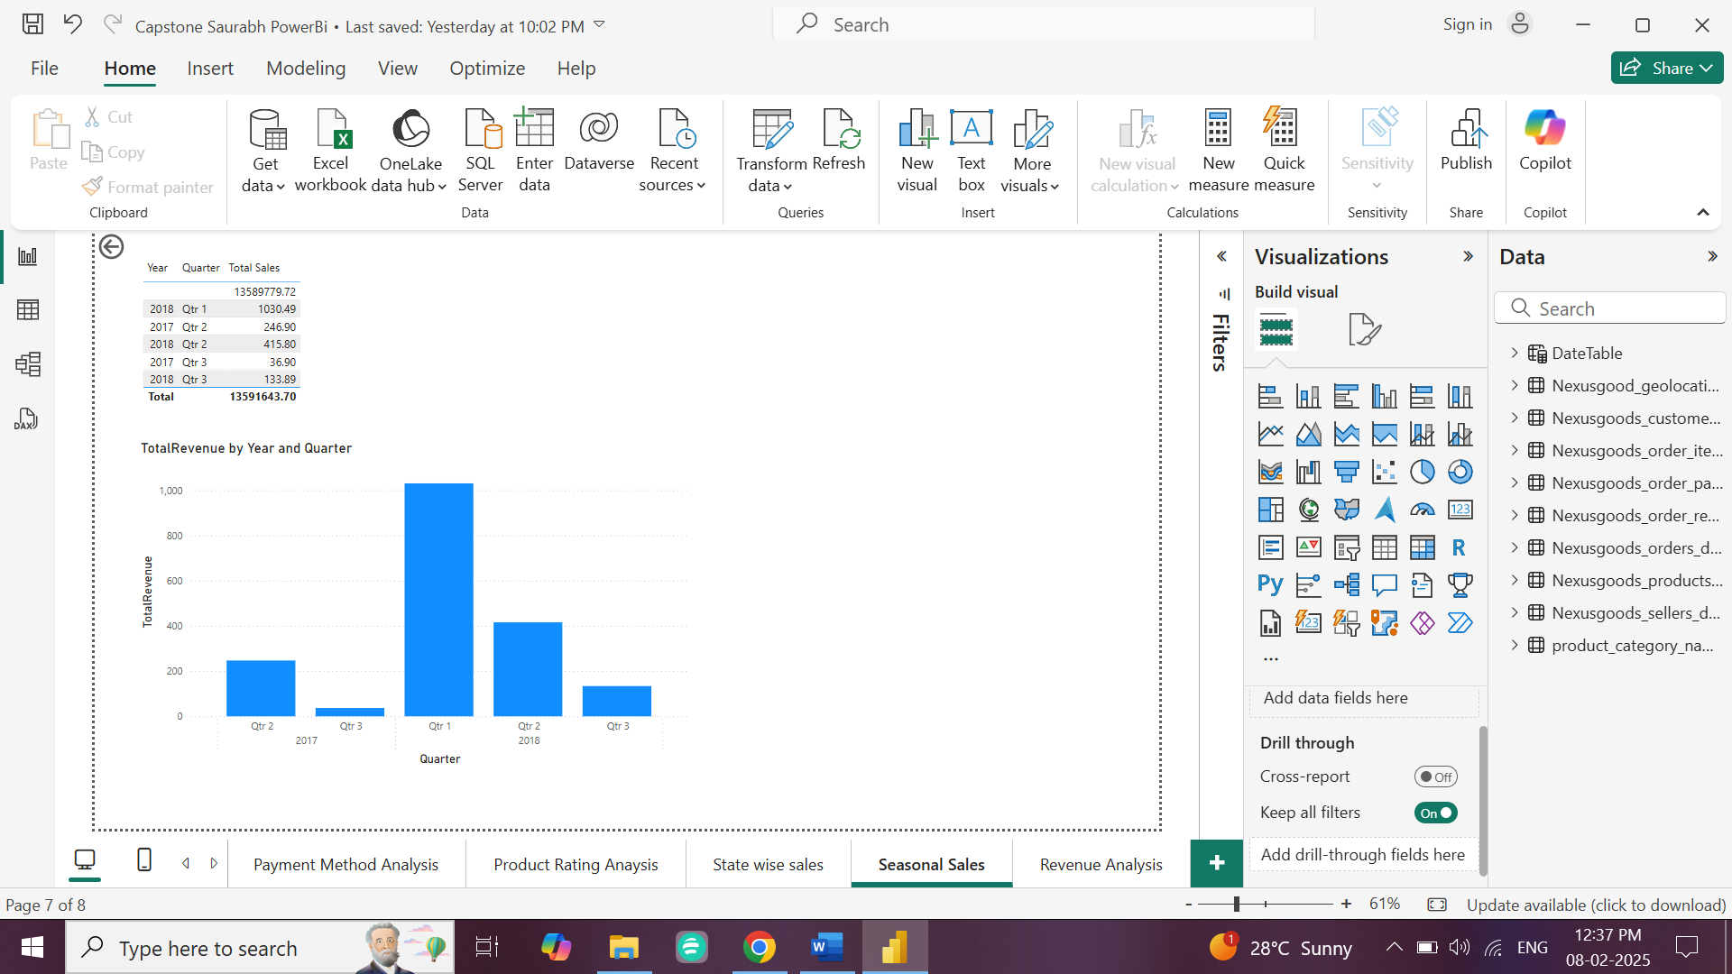

* As we can see that during initial stage revenue generated by Qtr. 2 and Qtr. 3 was less.
* While that in 2018 the revenue generated in Qtr. 1 and 2 were increased and good.
* We can observe that in Qtr. 3 in both the years revenue generated was less which indeed shows due to seasonal effect or logistic issues.
* **Determine the total revenue generated by Shop Nest Store and analyze how it changes over time (Yearly). Represent this information through suitable visuals to highlight trends and patterns.**

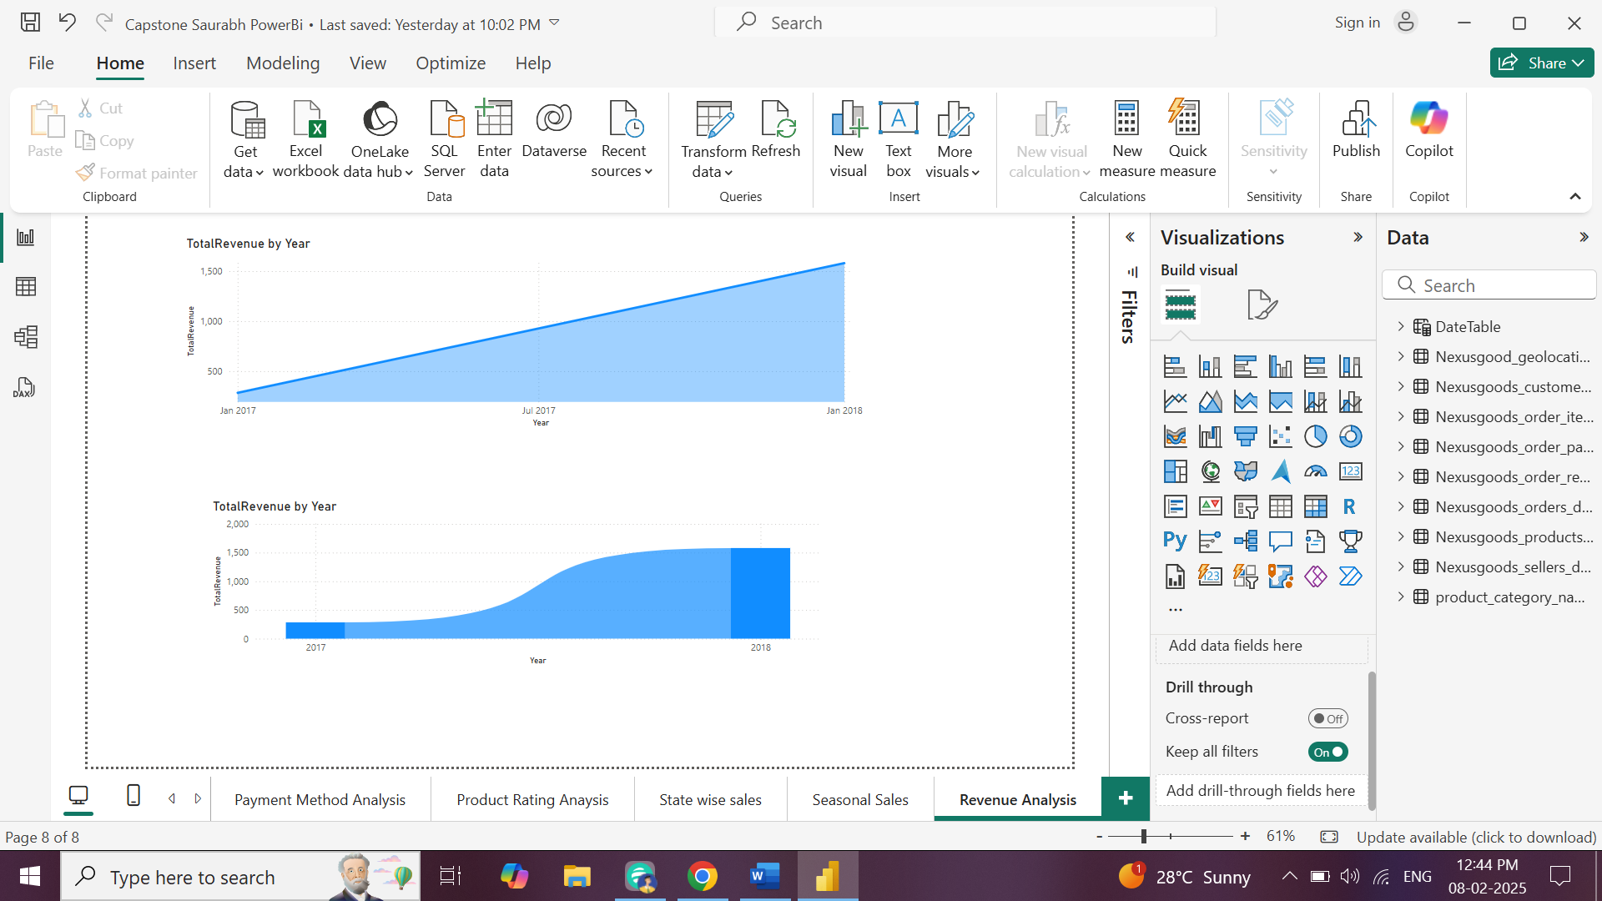

* From the visualisation we can see the consistent growth in sales as well as revenue generation.
* Also after July 2017 the growth has taken peak and started increasing consistently.
* During mid year growth we can see insight that because of seasonal growth or successful promotional growth can be seen here.
* Also during end of 2017 the slope becomes steeper down which shows new promotional activity or new product launches.
* In 2018 the growth shows highest due to expansion efforts or strong market presence.